Docker Task
Task Description:
Install docker on EC2 and explore the docker commands (docker images, containers, volumes, network)
EC2 instance launched
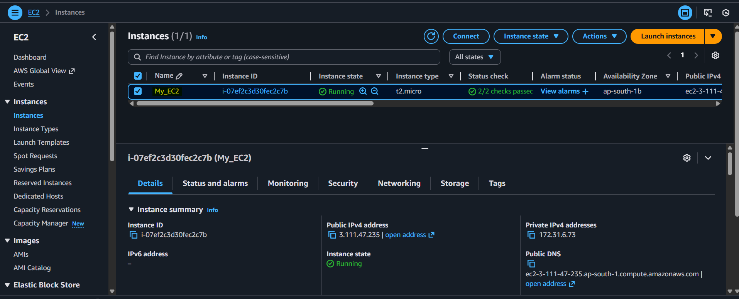
Login in to EC2 in ubuntu
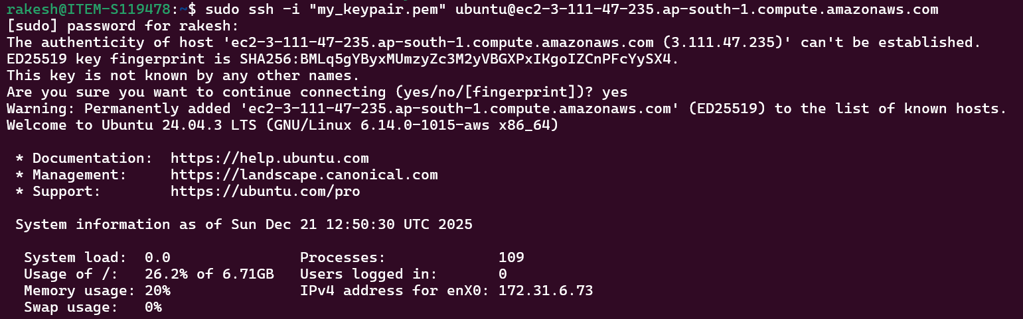
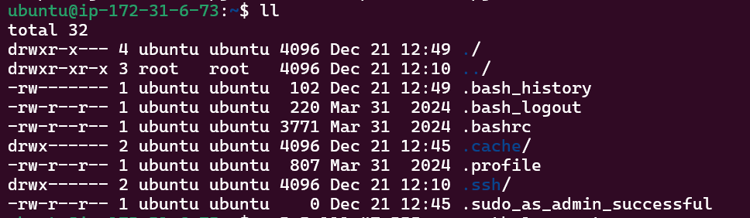
Install docker
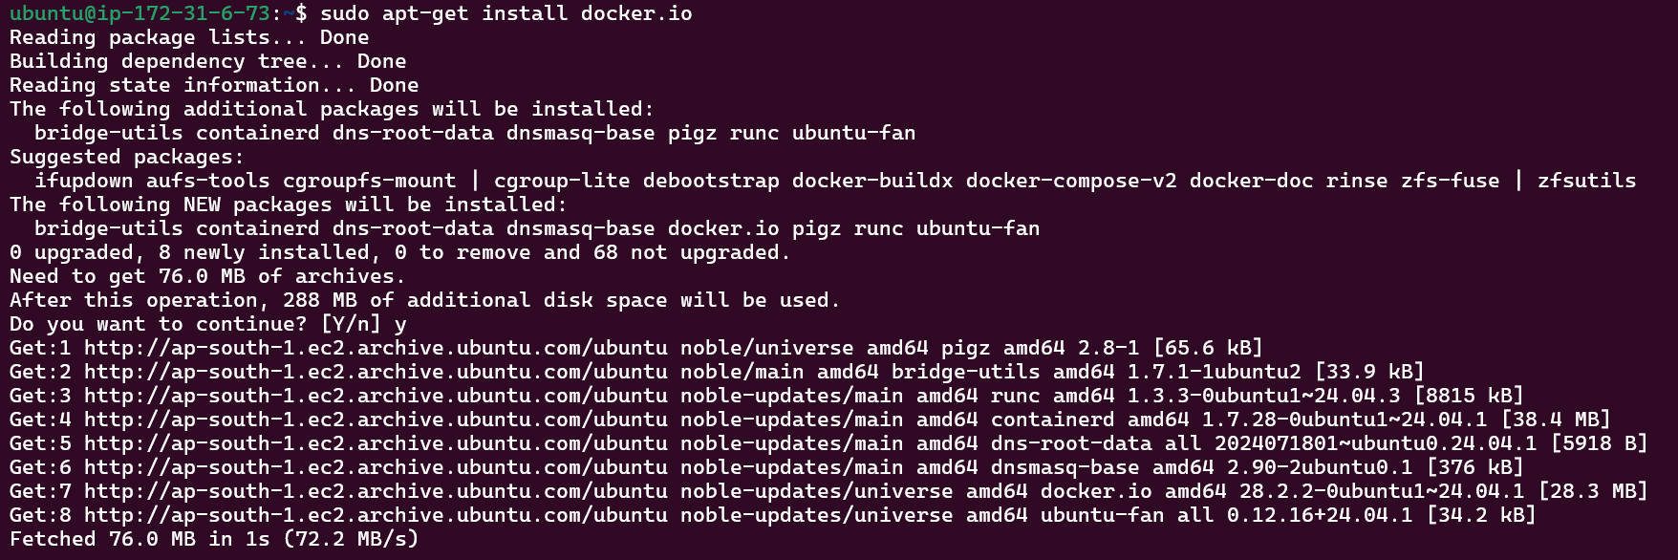
Enable docker
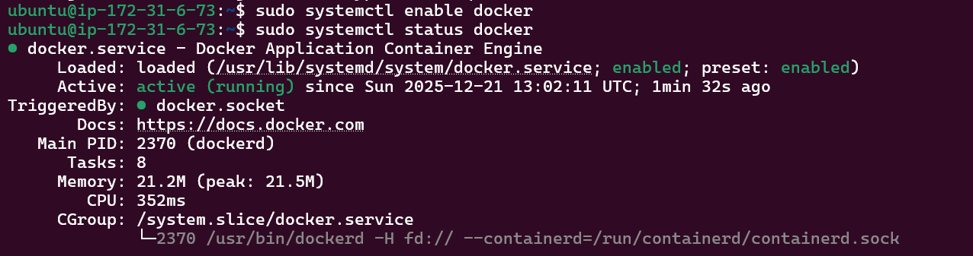
Install the python 3.15
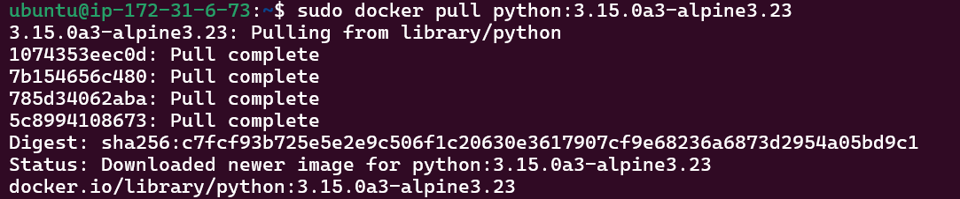
List the docker image
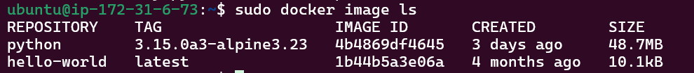

Install the latest python
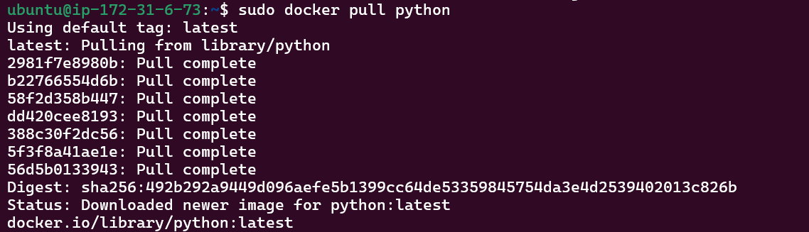
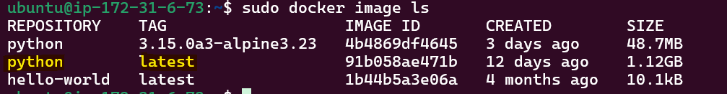
Delete the python latest version
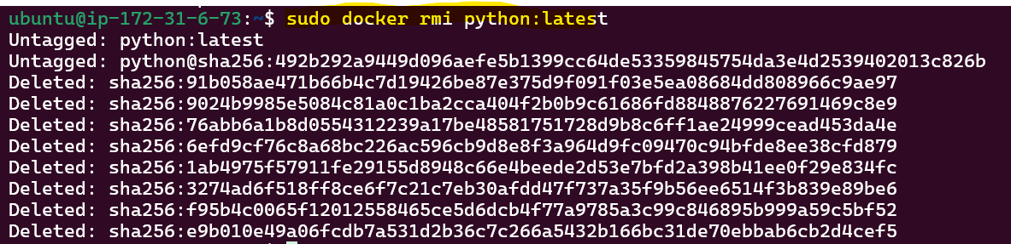
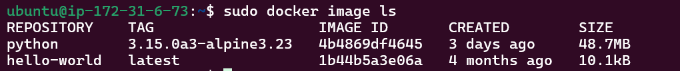
Run a container from an image.
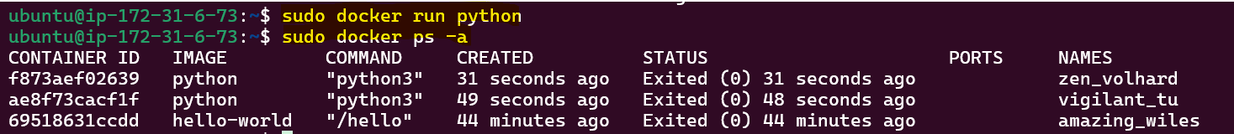

Run a container in interactive mode with a bash shell.
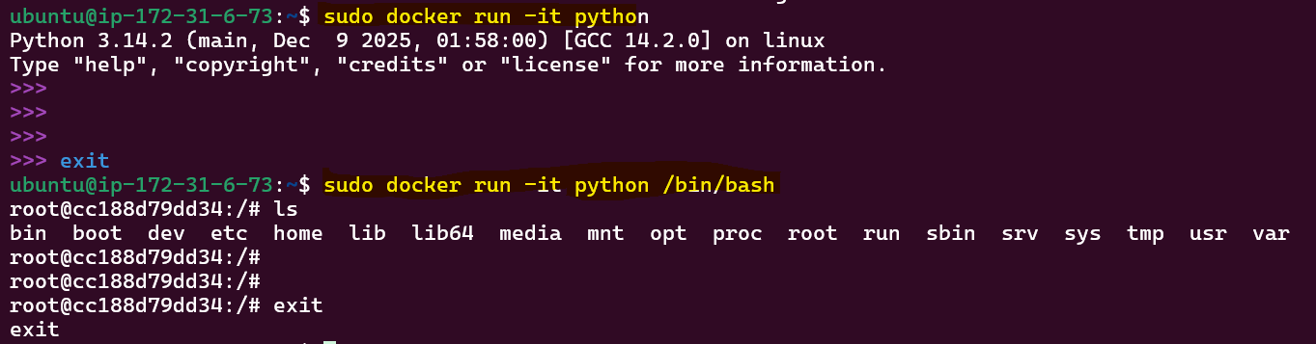
To check the running container.
Start a stopped container.
Stop a running container.
Remove a stopped container.

List all networks.
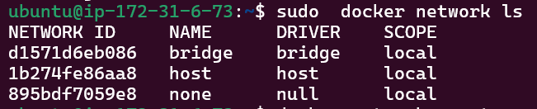

Create a new network.
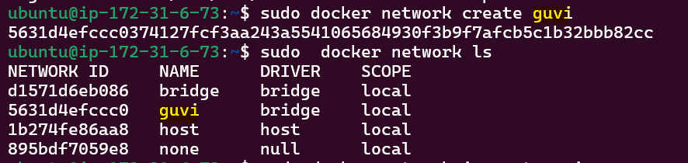
Display detailed information on a network.
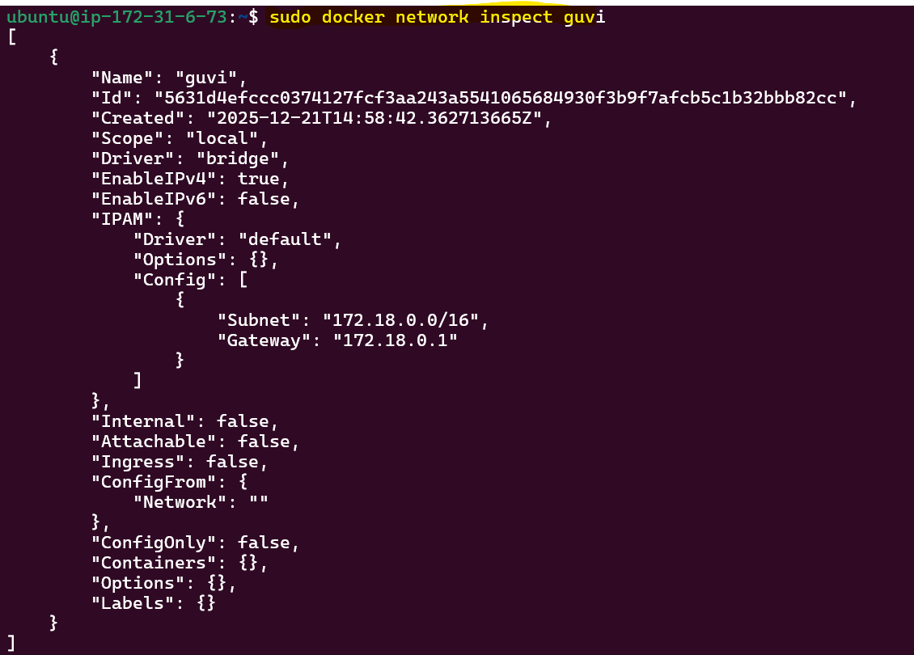
Connect a container to a network.
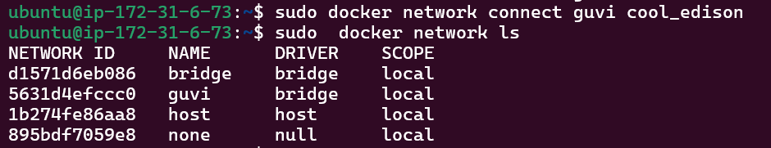

List all volumes.
Create a new volume.
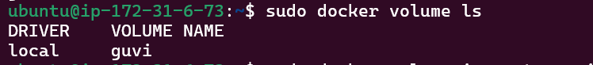
Display detailed information on a volume.
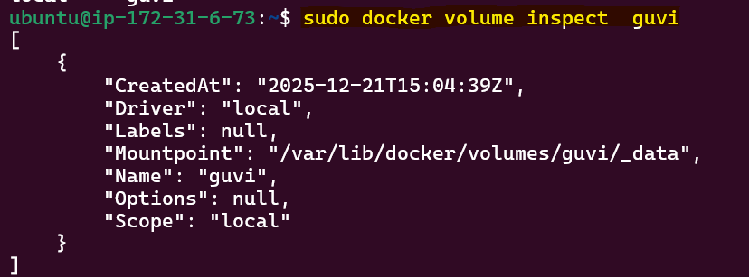
Remove a volume.
